

TASK 12

DBMS



June 1, 2023

**AKHTAR ALI**

**34241(BSSE)**

* ALL QUERIES

|  |
| --- |
| create table emp_copy AS select ename from emp; |
| insert into emp_copy values('NOMAN'); |
| select * from emp_copy; |
| update emp_copy set ename = 'AKHTAR' where ename = 'KING'; |
| savepoint A; |
| delete from emp_copy where ename='Haris'; |
| Rollback; |
| CREATE TABLE child_dept ( ID number(8) not null, name varchar(15),Block varchar(10),primary key (ID) ); |
| CREATE TABLE Student_AK ( ID number(8) not null, name varchar(15),Dept_ID number(10),primary key (ID), FOREIGN KEY(Dept_Id) REFERENCES child_dept(ID) ); |
| insert into child_dept values(7000,'SE','B'); |
| insert into Student_AK values(7000,'A',7000); |
| alter table Student_AK add constraint chk_id check(id>1); |
| CREATE VIEW emp_VU AS (select ename,empno,sal from emp where deptno != 30); |

* **QUERY no#1:**
* create table emp_copy AS select ename from emp;

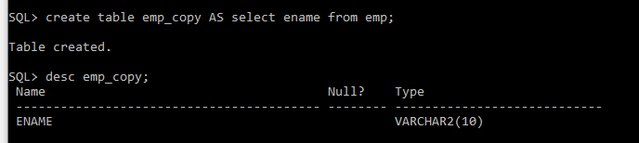

* **QUERY no#2:** insert into emp_copy values('NOMAN');

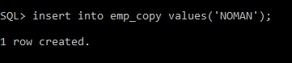

* **QUERY no#3:** select * from emp_copy;

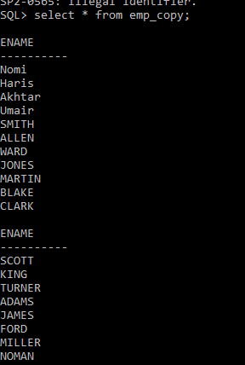

* **QUERY no#4:** update emp_copy set ename = 'AKHTAR' where ename = 'KING';

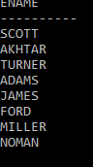 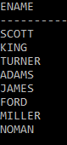

* **QUERY no#5:** savepoint A;



* **QUERY no#6:** delete from emp_copy where ename='Haris';



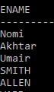 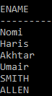

* **QUERY no#7:** Rollback;

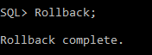

* **QUERY no#8:** CREATE TABLE child_dept ( ID number(8) not null, name varchar(15),Block varchar(10),primary key (ID) );



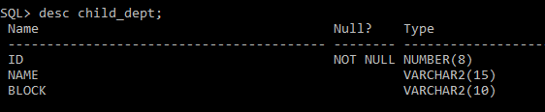

* **QUERY no#9:**

CREATE TABLE Student_AK ( ID number(8) not null, name varchar(15),Dept_ID number(10),primary key (ID), FOREIGN KEY(Dept_Id) REFERENCES child_dept(ID) );

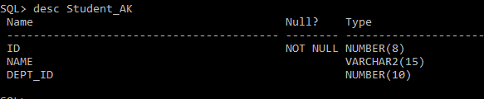

* **QUERY no#10:**

insert into child_dept values(7000,'SE','B');

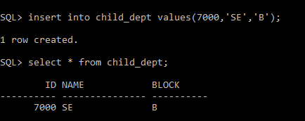

* **QUERY no#11:** insert into Student_AK values(7000,'A',7000);

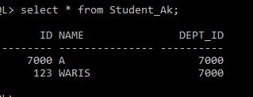

* **QUERY no#12:** alter table Student_AK add constraint chk_id check(id>1);



* **QUERY no#13:** drop Table Student_AK;

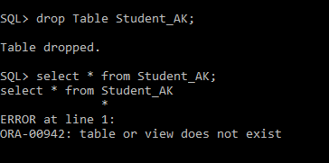

* **QUERY no#14:** CREATE VIEW emp_VU AS (select ename,empno,sal from emp where deptno != 30);

